Notice of Certificated Vacancy
The El Dorado Union High School District is accepting applications from qualified applicants for probationary and temporary positions for the 2020-2021 school year.
FILING DEADLINE  March 25, 2020  4:30 p.m. | SCIENCE  Physics and Engineering  (Project Lead the Way) | DISTRICT  OVERVIEW  The El Dorado Union High School District is located in the Sierra Nevada foothills between Sacramento and South Lake Tahoe.  The District’s boundaries encompass 1,250 square miles, including a large portion of El Dorado County’s historic Gold Rush region. The area includes about 40 communities along the highway 50 corridor, including the towns of Placerville, El Dorado Hills, Cameron Park, Shingle Springs, Diamond Springs, Camino, and Pollock Pines. A variety of new and existing homes, many with acreage, are available at reasonable prices within the District.  Agriculture, tourism, and light industry are the area’s primary industries. The community is served by Los Rios Community College District, Sierra Community College District, Cosumnes River Community College, California State University at Sacramento, and U.C. Davis.  The District’s location and natural setting provide for exciting outdoor activities with the Sacramento River Delta on the western border, Lake Tahoe resort and ski area on the eastern border and the American River.  The District serves 6,650 students in grades 9 through 12 and is comprised of four comprehensive high schools, a charter school, a Regional Occupational Program, and a continuation school.
Apply online at:  www.edjoin.org/eduhsd  EL DORADO UNION  HIGH SCHOOL DISTRICT  4675 Missouri Flat Road  Placerville, CA 95667  Human Resources  530.622-5081  or  916.933-5165  ext. 7228  Fax 530.622-5982  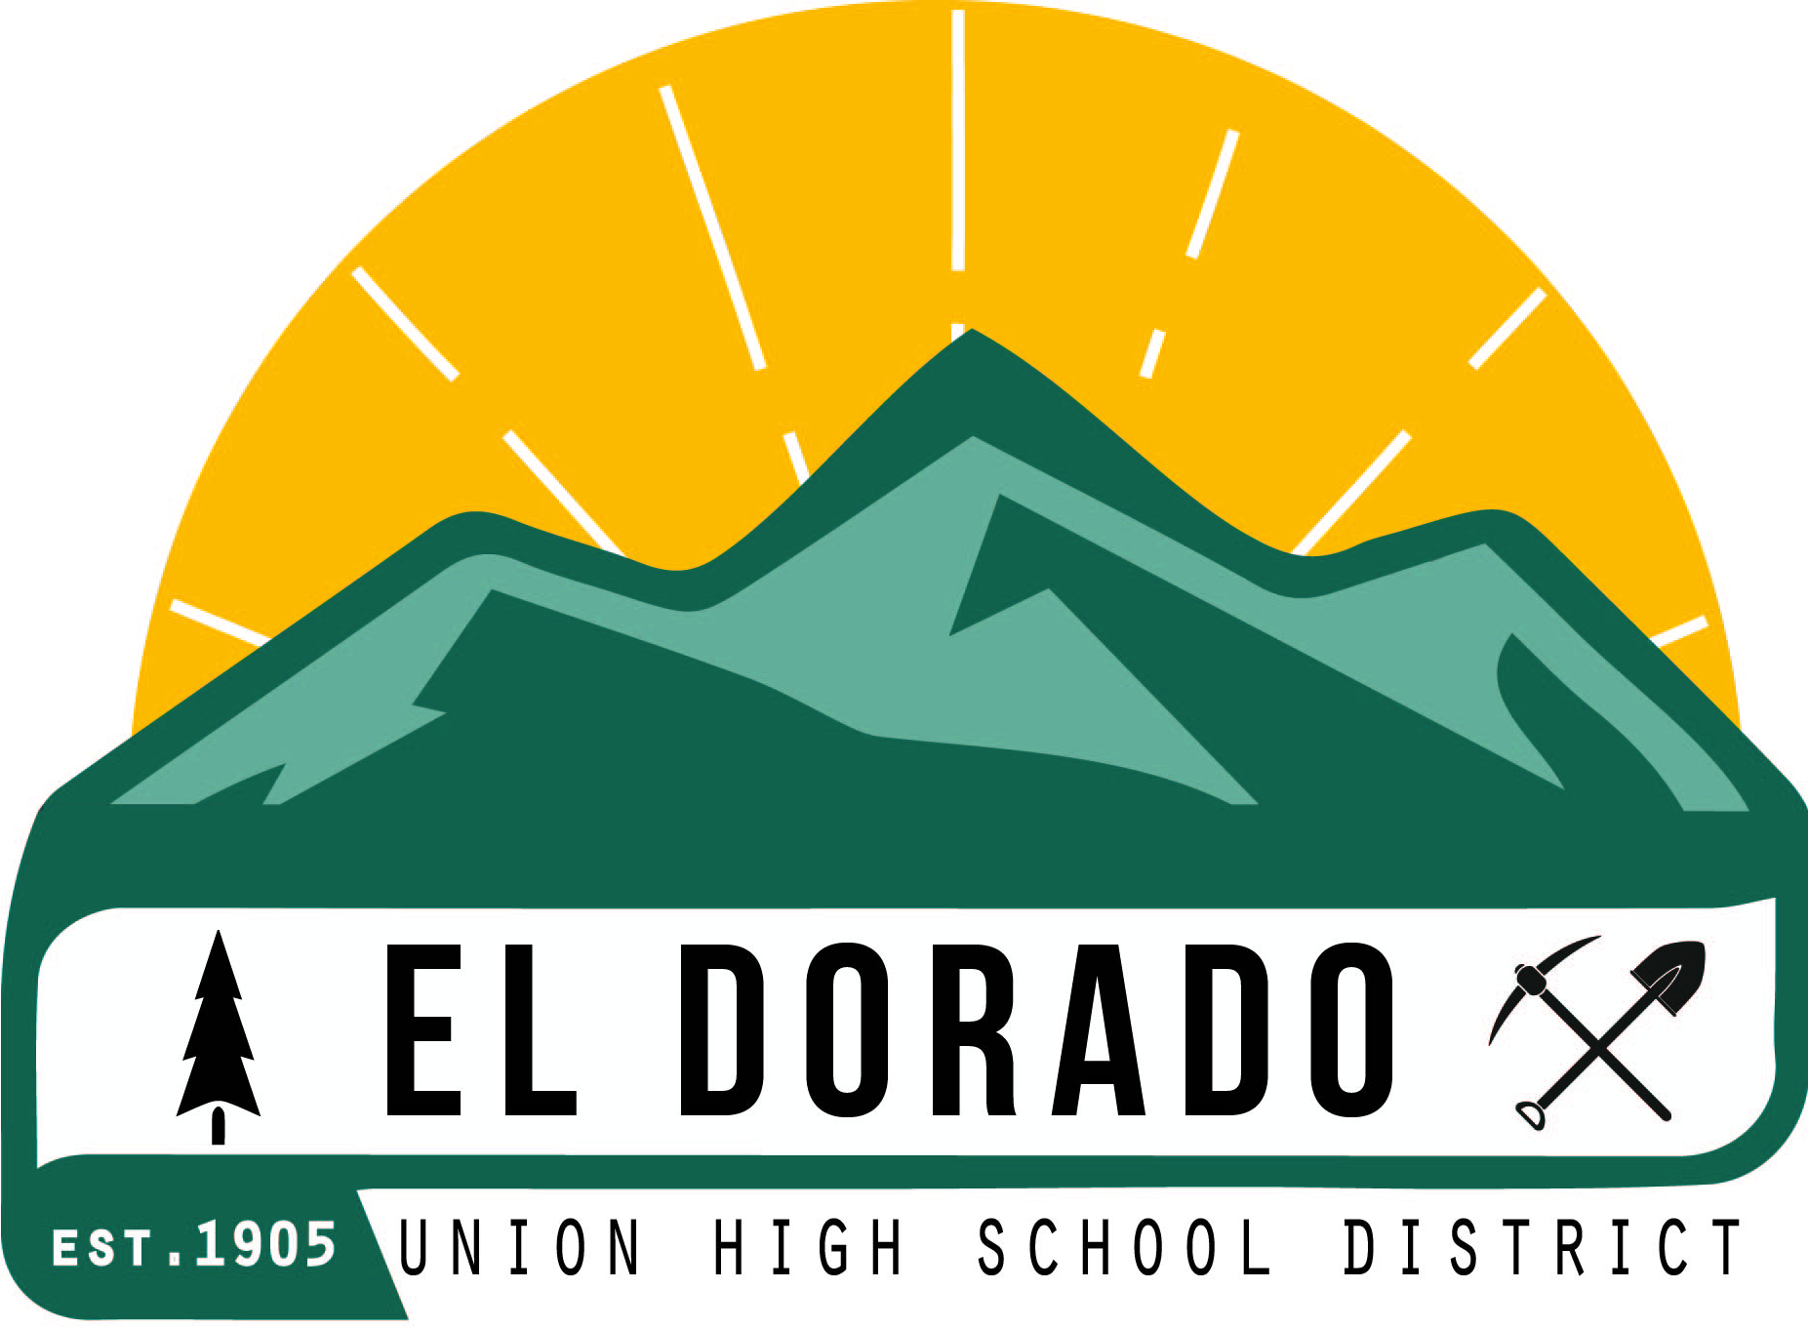 | SCIENCE  Physics and Engineering  (Project Lead the Way)
The successful candidates will possess the skills, knowledge, and abilities to:

- Teach skills, knowledge, and scientific attitudes in various science courses, utilizing the adopted courses of study;
- Plan a balanced science program involving demonstrations, lectures, discussions, and student experiments;
- Demonstrate scientific concepts by use of scientific apparatus and experiments;
- Instruct students in the proper use, care, and safe handling of science equipment;
- Participate cooperatively with the total staff in the development of a positive educational environment responsive to all students;
- Plan and adapt instruction in order to integrate appropriate strategies to meet the learning needs of all students;
- Use a variety of instructional strategies, resources, and technologies to meet students’ diverse learning needs;
- Maintain professional competence through participation in Professional Learning Communities, in-service education activities provided by the district, and/or in self-selected professional growth activities;
- Evaluate student performance and prepare applicable grade reports;
- Communicate and be available to parents and students to discuss individual student’s progress.

Requirements:
- Single Subject Credential in Physics or equivalent
- English Learner Authorization

This recruitment may include both full and part-time positions.

Apply online at: www.edjoin.org/eduhsd

THE DISTRICT IS AN EQUAL OPPORTUNITY EMPLOYER AND PROHIBITS UNLAWFUL DISCRIMINATION AND/OR HARASSMENT OF DISTRICT EMPLOYEES OR JOB APPLICANTS ON THE BASIS OF THE INDIVIDUAL’S ACTUAL OR PERCEIVED RACE, COLOR, ANCESTRY, NATIONAL ORIGIN, AGE, RELIGIOUS CREED, MARITAL STATUS, PREGNANCY, PHYSICAL OR MENTAL DISABILITY, MEDICAL CONDITION, GENETIC INFORMATION, MILITARY AND VETERAN STATUS, SEX, SEXUAL ORIENTATION, GENDER, GENDER IDENTITY, GENDER EXPRESSION, OR ASSOCIATION WITH A PERSON OR GROUP WITH ONE OR MORE OF THESE ACTUAL OR PERCEIVED

